

Q1 (0.5 point):

Software Requirements Specification

for

<Project>[Student must replace this line by the name of project in the exam paper]
Version 1.0 approved
Prepared by
<author>[Student must replace <author> by your full name and studentID]
<organization>[Student must replace this line by the name of the FU Campus you take the exam]
<date created> [Student must replace this line by the date you take the exam]

Q2 (2.5 points):
<Student must replace this line, answer Q2 by drawing 1 context diagram that reflects this exam paper and copy and then paste the image of that context diagram here
Notes:
- Draw the correct syntax to describe the context diagram
- Draw external entities
- Draw the data flows described in this exam paper
>

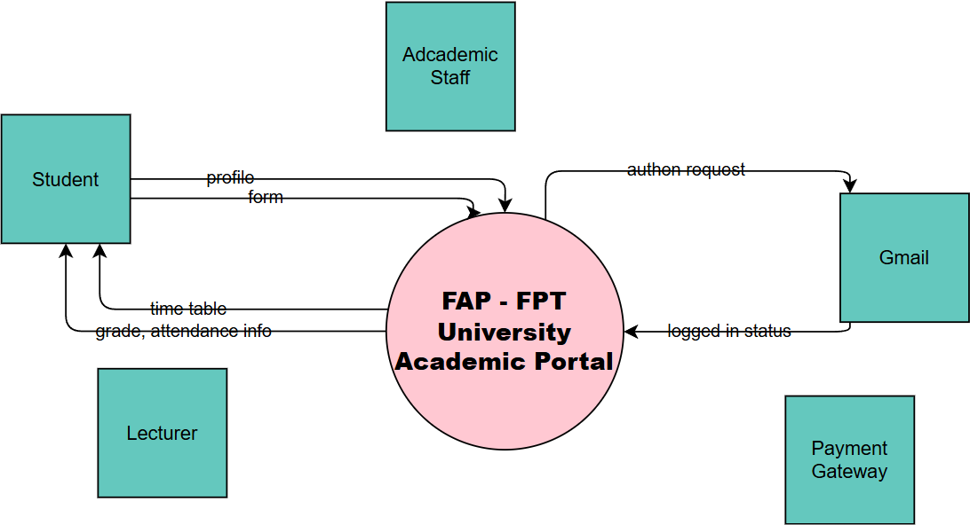

Q3 (4.0 point):
< Student must replace this line
Notes:
- Draw the correct syntax to describe the use case diagram
- Draw actors and brief descriptions
- Draw use cases and brief descriptions
>
<Student must replace this line, answer Q3 by drawing 1 use case diagram that reflect this exam paper and copy and then paste the image of that use case diagram here>

< Student must replace this line, briefly describe the actors of the diagram by fill the content to below table>
# | Actor | Description
01
02
03

< Student must replace this line, briefly describe the use cases of the diagram by fill the content to below table>
UC-01
UC-02

Q4 (3.0 points):
< Student must replace this line
Notes:
- Draw the correct syntax to describe the conceptual ERD
- Draw entities and brief descriptions
- Draw relationships
>
<Student must replace this line, answer Q4 by drawing 1 conceptual ERD that reflect this exam paper and copy and then paste the image of that conceptual ERD here >

< Student must replace this line, briefly describe the entities of the diagram by fill the content to below table>
# | Entity | Description
01
02
03

